## 

# Experiment #6: Sinusoidal Steady State

Christopher Badolato

Yajaira Varillas Perez

EEL3123C-0013

3/6/2019

## Objectives

## To understand and calculate the power factor of a passive circuit.

## To verify that resistive components dissipate power while reactive components do not.

## Equipment

## Breadboard

## Circuitry components

## Function generator

## Oscilloscope

## Digital multimeter (DMM)

Circuit

## 

## 

## 

## Simulations

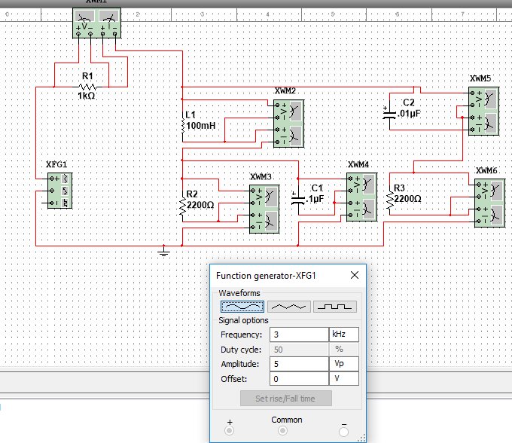

|  |
| --- |
| Measures of the power at each element using watt meters. To measure the power, we can place the wattmeters to measure voltages and currents and the meter will perform the calculation |

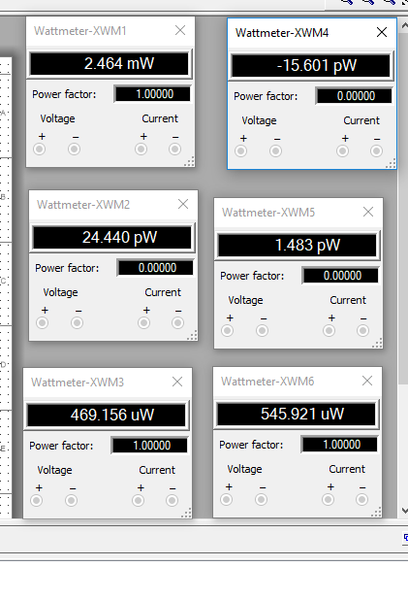

|  |
| --- |
| Power measurement of each element from the circuit using the watt meters above. |

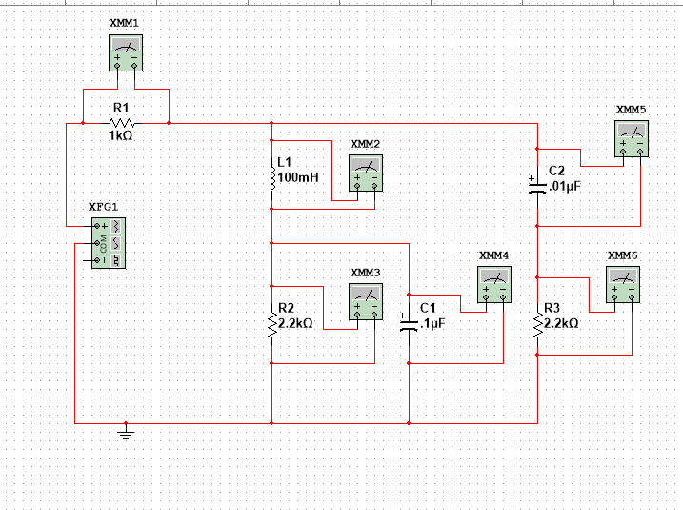

|  |
| --- |
| Using the above DMM we measured the voltage of each element, the data from each DMM is below. |

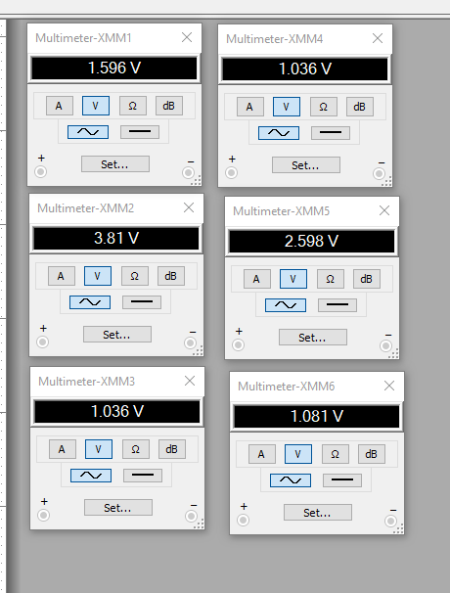

|  |
| --- |
| Voltage of each element, corresponds to the simulation, found using DMM. Each was numbered the same as the watt meters above. |

Measured values from experiment

|  |  |
| --- | --- |
| R1 = 1000Ω | 1.5296 V |
| I = 100mH | 3.5716 V |
| R2 = 2.2kΩ | 0.976 V |
| = 0.01 $μ$ F | 0.9758 V |
| = 0.1F | 2.458 V |
| R3 = 2.2kΩ | 0.9792 V |

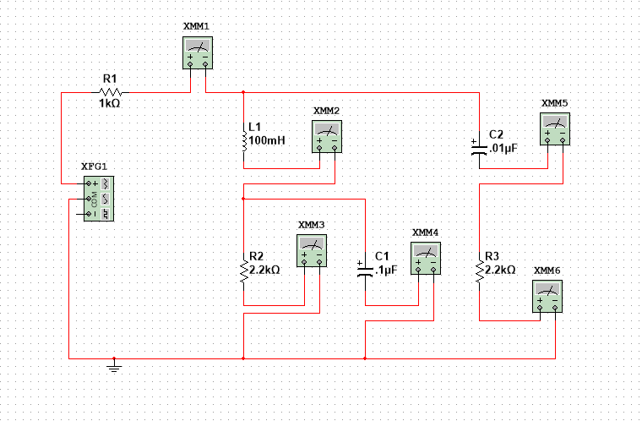

|  |
| --- |
| Placing a DMM in series with each element we can measure the current of each element in the circuit. |

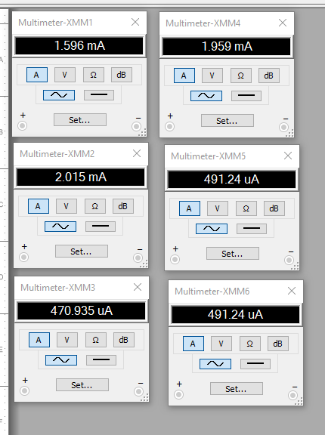

|  |
| --- |
| Current of each element. Placing a DMM in series with each element we measured the current.  These values match our measured and are also similar to our calculated values. |

Measured values from experiment:

|  |  |
| --- | --- |
| R1 = 1000Ω | 1.5565 mA |
| I = 100mH | 1.9117 mA |
| R2 = 2.2kΩ | 0.4435 mA |
| $C_{1}$ = 0.01 $μ$ F | 1.8411 mA |
| $C_{2}$ = 0.1 $μ$ F | 0.4456 mA (445.6 A) |
| R3 = 2.2kΩ | 0.4464mA (446.4 $μ$ A) |

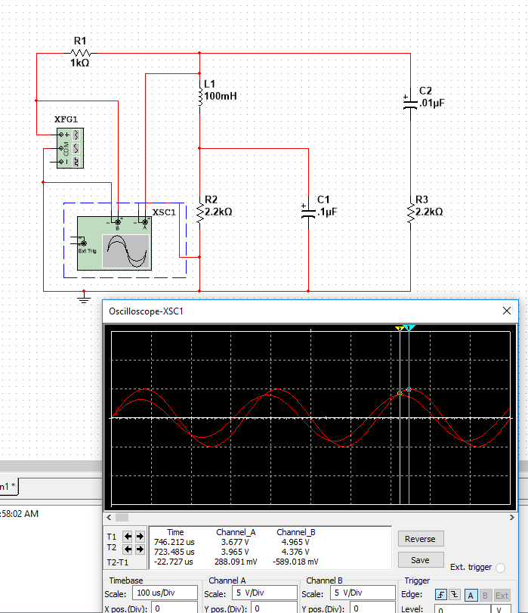

|  |
| --- |
| As we can see from above, our time difference is 22.722 $μ$ s between our peaks of $V_{mx}$ and $V_{m}$. These values are similar to our preparation and allowed us to continue with our experiment with confidence.  The law of conservation of energy is proven to show that the average power dissipated equals the total power applied to the circuit. This can be proven by our numerical values for power. |

# Experiment

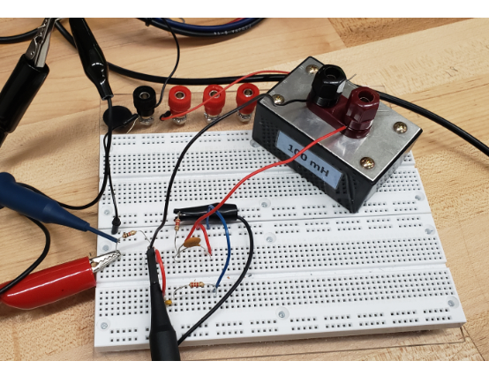

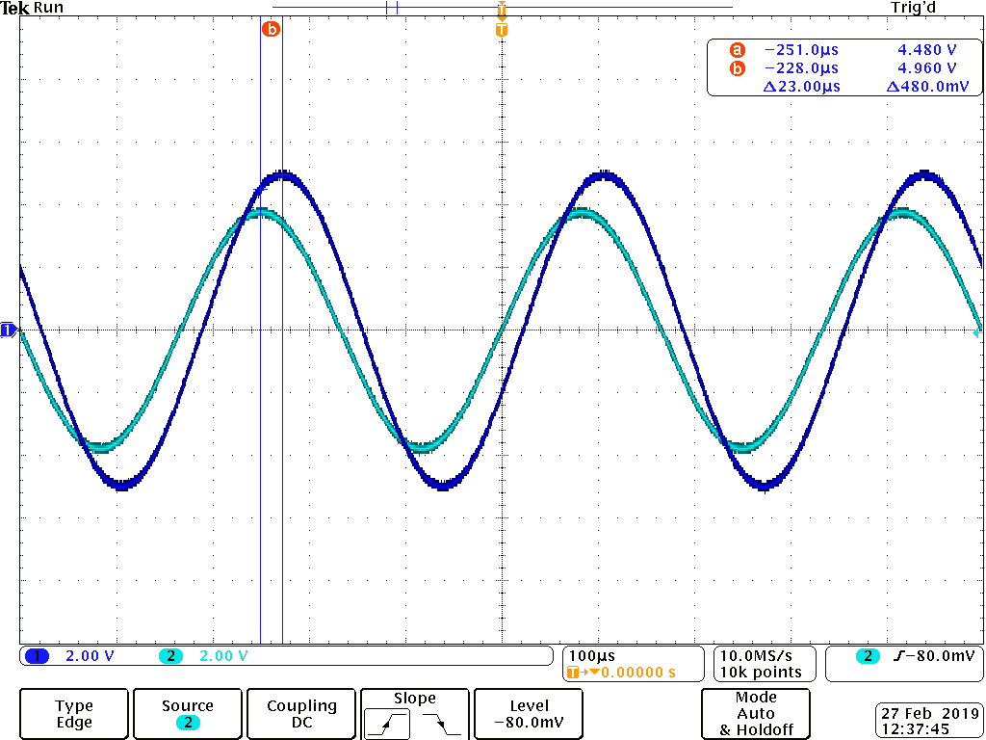

|  |
| --- |
| 1. After building the circuit on the breadboard, using one of the oscilloscopes channels connected in series with our $V_{x}$ to display our $V_{x}$, as well as another channel connect across $V_{in}$. The two curves have the same frequency with a slight phase shift as shown in the image above. With these curves, we can calculate the power factor angle.  2. We measured the time difference between the two peaks to calculate our value for ɸ : $V_{mx}$ = 4.48 V $V_{m}$ = 4.96 V $ɸ = 2π × f × Δt$ $ɸ = 2π× (3 × {10{}^{3}}^{})Hz× (25 × {10{}^{-6}}^{})s{}^{}$ $ɸ$ = 0.4524 rad $⋅$ s  In degrees:  )|  )|  θ = 64.58° |
| 3. Using the equation below, we can calculate our power factor (ratio of average power to apparent power):  Power Factor = cos(θ)  cos(64.58°) = 0.429 |
| 4. Our voltage and current measurements are on pages 5 and 7, respectively, for easy comparison to the simulated values. |
| 5 Calculate the average power dissipated in each element.   |  |  |  | | --- | --- | --- | | Element | Calculation | Power (mW) | | R1 = 1000Ω | 1.5296 V | 2.3808 mW | | I = 100mH | $1.9117 mA × 3.5716 V$ | 6.8278 mW | | R2 = 2.2kΩ |  | 0.43277 mW | | = 0.01 $μ$ F | $1.8411 mA ×0.9758 V$ | 1.80225 mW | | = 0.1 $μ$ F | $0.4456 mA ×2.458 V$ | 1.09528 mW | | R3 = 2.2kΩ |  | 0.43715 mW |   These values are very close to our measured values, even though the power for some of the elements is much lower in the simulation than measured. |
| 6. Total power provided by the voltage source:  Output Current = 1.5521 mA  Output Voltage = 3.5664 V  Total Power = $1.5521 mA ×3.5664 V$ = 0.553578 mW |
| 7. Comparing this result with that from the preparation and the simulation, we can see that the values are relatively close to the original values found in the simulation and the preparation. |

|  |
| --- |
| 8. We can conclude that the real power delivered by the source is essentially completely absorbed by the non-reacting aspects of the circuit. Any power provided by various sources will primarily only dissipate across the non-reactive components in this circuit. |

Conclusion

The purpose of this lab was to observe the steady-state response that exists after the initial condition and the transient response die out. Since the voltages and currents are sinusoidal, we can determine the steady state response with AC steady state analysis. We found the power factor by first finding $V_{m}$, and $V_{mx}$, which are located at peaks of our output voltage and our input voltage. We measured the time difference between these peaks. Using this time difference, we can calculate the power factor angle. Finally, using this power factor angle, we can calculate the average and reactive power of the circuit. Power factor is the ratio of the average power to the apparent power. We can confirm that the phasor transform will yield a correct analysis of the circuit.